**Introduction to Mailgun**

Mailgun is an Email automation service. It has a very powerful set of inbuilt functions for sending emails. Developers can process their email with the help of Mailgun API

**Creating an account on Mailgun**

Step 1: Open <https://www.mailgun.com/> in browser.

Step 2: Click on [Sign Up](https://signup.mailgun.com/new/signup) button.

Step 3: Fill all the necessary details in SIGN UP form. Make sure you are unchecking the payment option. Below is the screenshot of filled sign up form.

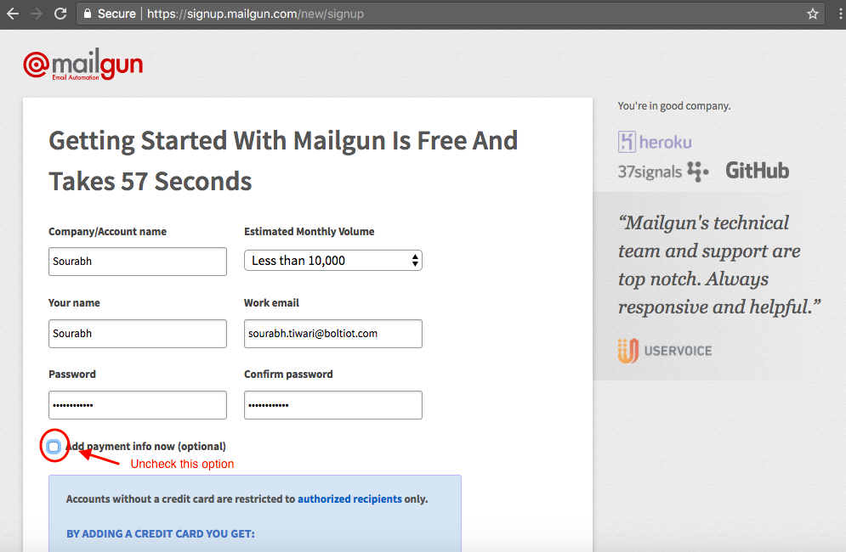

Step 4: You will get a verification mail having a link. Click on that link to verify your mail.

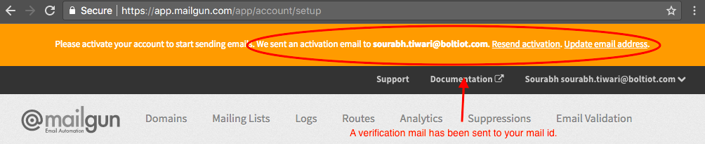

Step 5: To verify they will ask for phone number. Choose India as an option in the dropdown and then enter your phone number.

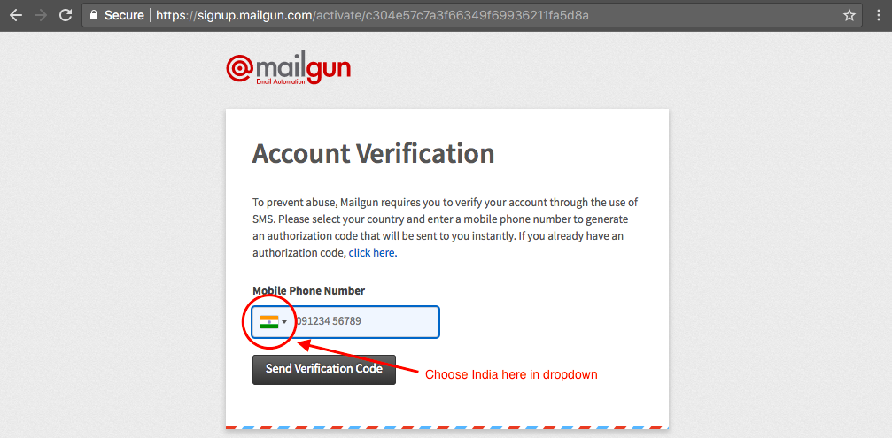

Step 6: After verification, scroll down to Sandbox Domain section. Click on Add Recipient button.

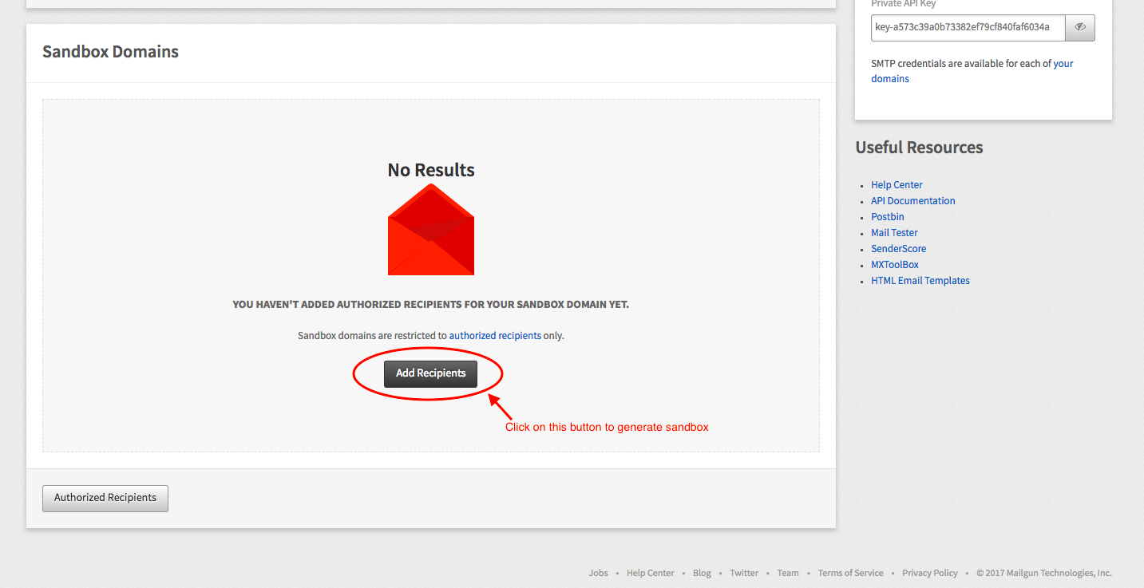

Step 7: Click on Invite New Recipient button.

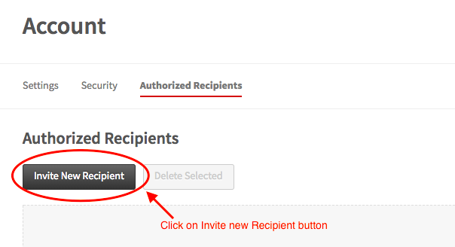

Step 8: Enter the Receipient Email ID. In this case enter your Email ID.

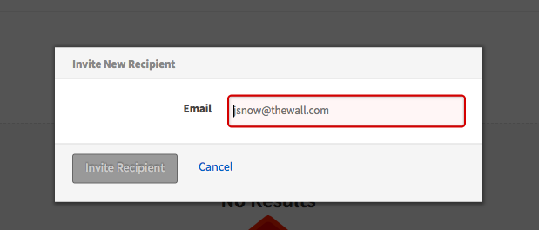

Step 9: After adding Email ID a new sandbox will be generated. Click on the ID of the newly generated sandbox. Refer below image for the same.

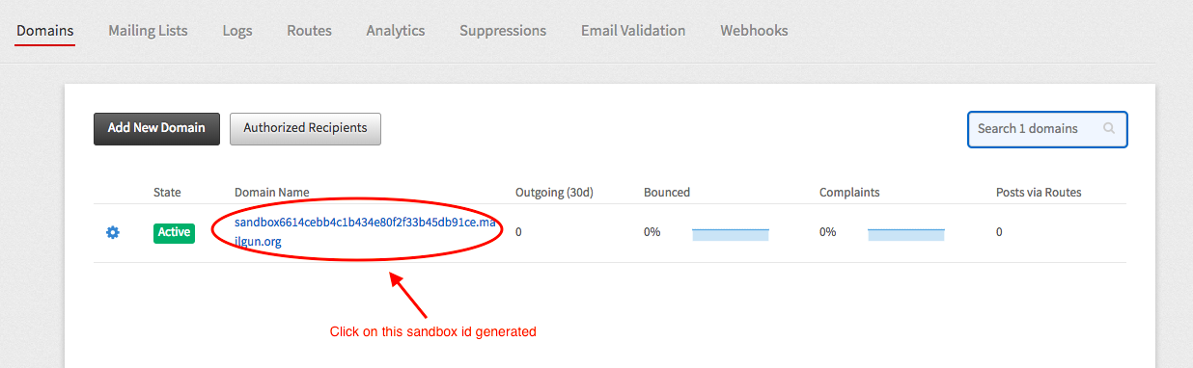

Step 10: The new screen will have all the necessary credentials that you want for sending an email. Copy all this credentials and save in the notepad.

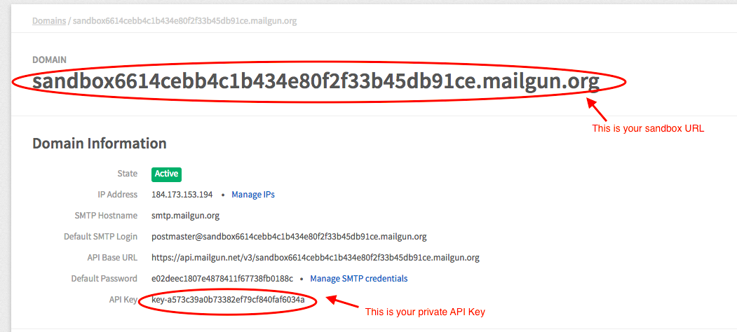

That's it. You have successfully created the account on Mailgun.